|  |  |
| --- | --- |
| **Ex No: 6.4**  **Date: 11-09-2024** | **Denoising with a CNN Autoencoder on Fashion MNIST** |

**Objective:**  To build and train a convolutional autoencoder that removes noise from the Fashion MNIST dataset by learning compressed representations of the noisy input data and reconstructing the original clean

**Descriptions:** This lab focuses on implementing a denoising autoencoder using convolutional layers for the Fashion MNIST dataset, where noise is added to the images. The autoencoder will learn to filter out the noise and reconstruct clean images. The input images are normalized and noise is introduced by adding random Gaussian noise. The CNN-based encoder extracts compressed features, and the decoder reconstructs the denoised images.

**Model:** The model consists of:

* **Input Shape:**

· 28x28x1 (grayscale image of Fashion MNIST).

* **Encoder:**
* Convolutional layers with filters and ReLU activation to downsample and extract features.
* Max-pooling layers for dimensionality reduction.
* **Decoder:**
* Transposed convolution layers to upsample and reconstruct the image from the encoded features.
* Sigmoid activation to ensure pixel values are in the [0,1] range.
* **Loss Function:**
* Binary crossentropy for comparing original and reconstructed images.
* **Optimizer:**
* Adam optimizer for training.

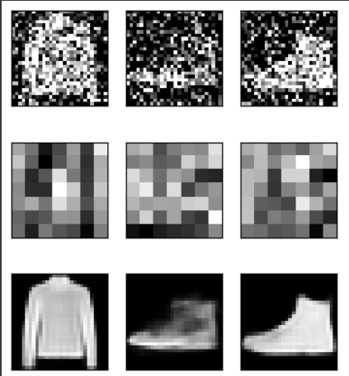

**Results:**

· After training the model for 50 epochs, it successfully reconstructs the denoised images from noisy input.

· The autoencoder learns to remove noise while preserving the essential features of the images.

· Visualization of the noisy input, encoded representation, and reconstructed denoised images shows the ability of the CNN-based autoencoder to filter out the noise.

**Conclustion:**

The CNN autoencoder was able to effectively remove noise from the Fashion MNIST dataset, demonstrating the power of autoencoders in denoising tasks. The convolutional layers improved the model's ability to capture spatial features, making it suitable for image-based denoising applications.

**GitHubLink:** GitHub Link: https://github.com/princeranjan789